POPCHAIN APP Product Design Specification

Version： | V1.0.2 | No： | TH-TL-POP-05
Security level： | A+ | Department/Project: | R&D Department
Product： | POPCHAIN APP Product design | Subsystem:

About the book
Overview
- This book is the POPCHAIN APP product design specification of the blockchain project of the POPCHAIN Foundation–.
- POPCHAIN Foundation provides the hardware and software design and the implementation solutions for the project.
- POPCHAIN Foundation has the final right to modify and interpret this document and the program.

Contents
About the book 2
I. Introduction 4
1. Purpose 4
2. Scope 4
II. User Role Description 5
III. Product Overview 6
1. POPCHAIN Main Function Description 6
IV. Product feature 7
1. Account management 7
2. Device 10
3. Search 11
4. Mine 12
V. Other Product Requirements 16
1. Compatibility Requirement. 16
VI. Risk Analysis 17
VII. Project Module Table 18

Introduction
This document mainly defines the detailed description of the POPCHAIN version function and the content and the logic of each module of the front-end page.

Purpose
The purpose of this document is to clearly and hierarchically define the source of the content and associated logic for each module in the page prototype.

Scope
This document mainly describes the function in the POPCHAIN front-end page, the corresponding background management function support, partial interaction details, and the technical requirements involved and achieved. The main readers of this document are front-end engineers in the technical department, back-end engineers, and visual designers in the visual department.

User Role Description
User Role Description | User Description
Registered User | User has a registered POPCHAIN account
Unregistered User | User does not have a registered POPCHAIN account

Product Overview
POPCHAIN app is a mobile app for POPCHAIN mining and POPBOX device management, and supports Android and iOS mobile systems.

POPCHAIN Main Function Description
- Login / Registration and Account Management
- Device Information Display
- Income and Withdrawal function
- Device Binding and Unbinding
- Basic System Settings

Product feature

Account management
- Registration / Login
- Registratio
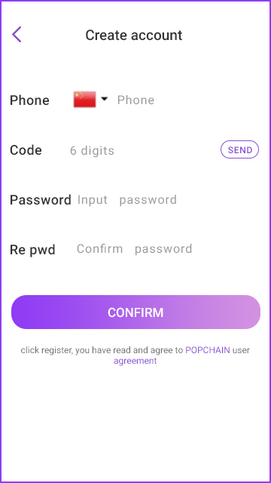
[Create account]

User Scenario | New users need to register for their own accounts
Function | Users register with their mobile phone numbers
Priority | High
Input / Pre-condition | Start APP/ the network is normal
Requirement | 1. Mobile phone number  2. Phone verification code  3. Password  4. Passwordconsistency
Output / Post-condition | Correct data / Back to the home page.
Note | Select the correct mobile phone number attribution area code

- Login
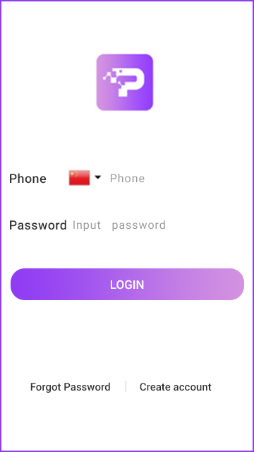
[Login]

User scenario | The user logs on to the system after registration
Function | User login operation
Priority | High
Input / Pre-condition | Account registration is complete.
Requirement | - Corresponding area code to the account’s phone number  - Phone number  - Login password
Output / Post-condition | Password verification / The system’s homepage

- Forgot password
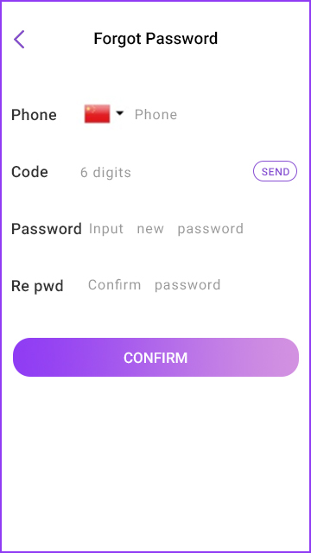
[Forgot Password]

User Scenario | Users who already have accounts, reset their passwords
Function | reset passwords
Priority | High
Input / precondition | Start APP, the network is normal
Requirement | 1.The user has a registered account  2.Phone verification code  3.Password
Output / postcondition | The user with a registered account, resets the password

Device
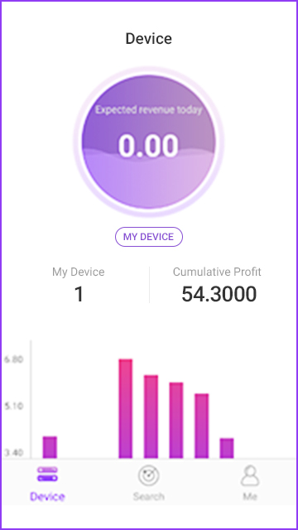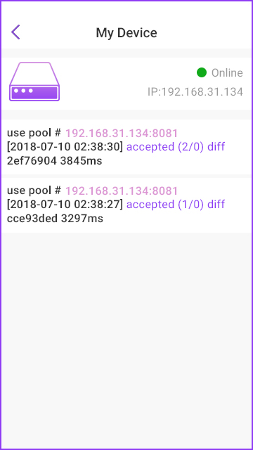
[Device]

User Scenario | Device home data
Function | Display equipment information and revenue data
Priority | High
Input / Pre-condition | The user is logged on.
Requirement | 1. Display the number of devices that the user is bound to.  2. Display the daily expected revenue and accumulated revenue of the user.  3. Display user revenue history data.  4. Graphical display of the last 7 days of data.  5. Display user device information.

Search
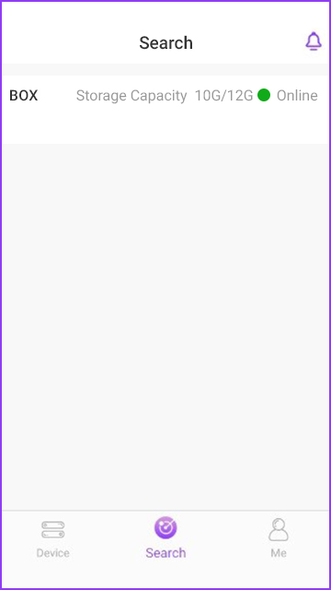
[Search]

User Scenario | The device connected by the current user
Function | The device connected by the current user
Priority | High
Input / Pre-condition
Requirement
Output / Post-condition | User connects devices

Mine
- Mining
- Coin Withdrawal
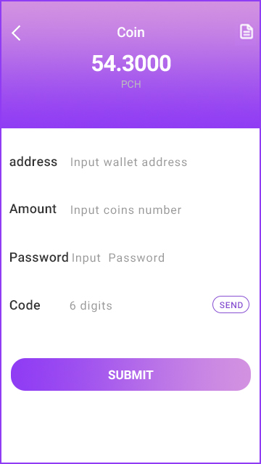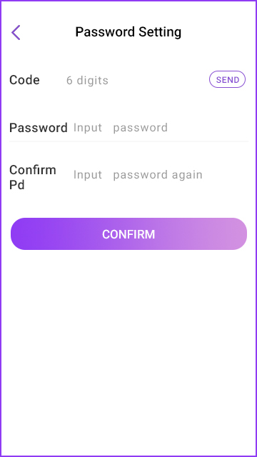
[Coin Withdrawal]

User Scenario | Users withdraw coins.
Function
Priority | High
Input / precondition | Go to this page
Requirement | - Enter the withdrawal address  - Enter the amount of withdrawal  - Enter fund password  - Enter verification code
Output / Post-condition | The number of Coin is greater than 0, and the capital password is set

- Fund Password Settings
[Password Setting]

User Scenario | Set fund password
Function | Set fund password
Priority | High
Input / precondition
Requirement
Output / postcondition
Note

- Settings
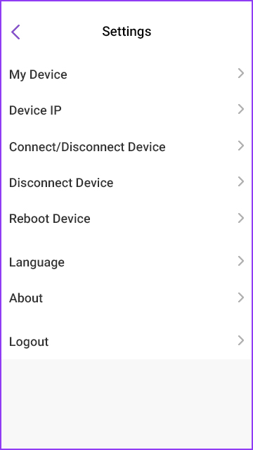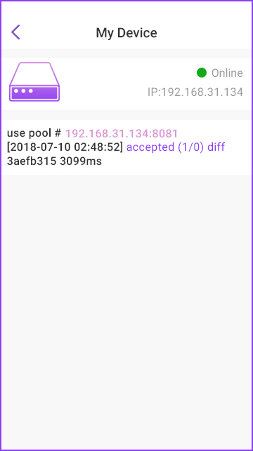
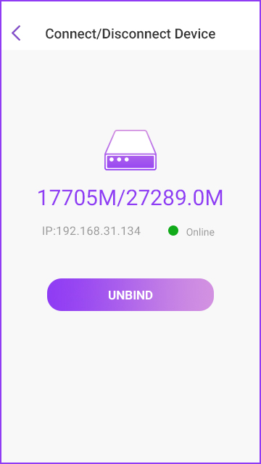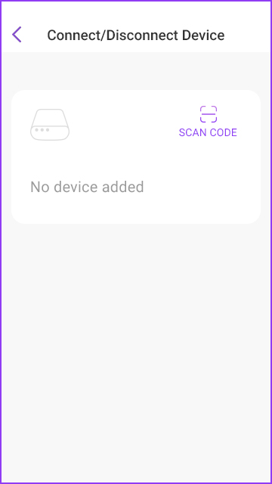
[Settings]

User scenario | System settings
Function | System settings
Priority | High
Input / precondition
Requirement
Output / postcondition
Note

- About Us

[About Us]

User Scenario | View the version number of APP, or update the APP
Function | Provide APP version, copyright statement related information
Priority | Low
Input / Pre-condition
Requirement | 1. Display version number  2. Latest version detection function  3. Copyright can be added at the bottom (market needs)
Output / Post-condition
Note

Other Product Requirements

Compatibility Requirement.
Android 4.5 or above; iOS 8.0 or higher.

Risk Analysis
Risk | Possibility | Severity | Strategy | Responsiveness

Project Module Table
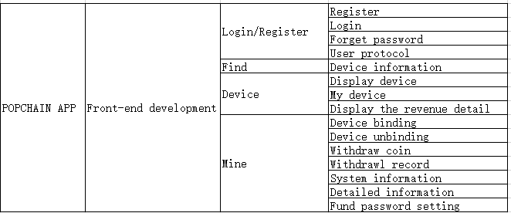
[Project Module Table]

